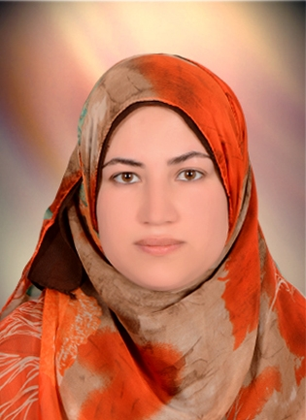
\
Ghada Hassan Ahmed Mohammed

Address : Alwasta_Alfath centre_Assiut
Mobile : (+20 )01005790410
Home tel : (088)2461139
E-mail :baird_happy@yahoo.com
:gh_hassan@aun.edu.eg

Education :

- Graduated from faculty of Medicine ( Bachelor of Medicine and surgery) - Assiut University.
- Graduation Year ,September 2004
- Degree : Excellent
- Having the Master Degree in internal Medicine 2009
Skills:

- Computer Skills:
- Holding an electronic learning course certificate
- Good use of the internet
- Good Knowledge of (Ms.Office – Ms.Windows)
- Language Skills:
- Native language Arabic.
- Holding ELPT course Certificate
- Passed level 2 In The English language
- excellent command of both written and spoken English.

- Personal Skills:
- Ability to work under pressure.
- Ability to work with all levels of management and personnel.
- Ability to merge into new communities and life style.
- Patient, ambitious and high self-motivated.
Experience and other courses :

- Worked in The Internal medicine Department in Assiut university Hospital for 10
- years till now.
I passed the courses of developing ablilities of faculty members in 2015
Personal Data:

- Date of Birth 16/ 9 / 1981
- Gender Female
- Nationality Egyptian
- Marital Status Married

